Technical Report: Week 4 – Data Acquisition, Collection & Governance
Project Title: Non-Mortgage Living Expense Estimation Engine
Target Scope: Harris County (48201), Fort Bend County (48157), and Galveston County (48167) — 279 Unique ZIP Codes
Phase: Data Acquisition, Pipeline Setup, and Governance Framework

1. Data Identification & Ingestion Matrix
To accurately model non-mortgage living costs, nine primary multi-domain datasets were identified, acquired, and organized into the project repository.
Data Domain | Raw File Name / Dataset | Format / Size | Source Agency / Entity | Core Pipeline Utility
Geographic Base | Geo_HUD_USPS_ZIP_County_Crosswalk_2026-06.xlsx | .xlsx (~2.4 MB) | U.S. Dept. of Housing & Urban Development (HUD) | Establishes the 279 canonical ZIP code index and county FIPS crosswalk.
Flood Insurance | NFIP Redacted Claims Texas.csv | .csv (1.07 GB) | FEMA / National Flood Insurance Program (NFIP) | Historical flood claim frequencies and average building/contents payouts.
Spatial Hazards | Geo_FEMA_Flood_Zones_Harris.zip  Geo_FEMA_Flood_Zones_FortBend.zip  Geo_FEMA_Flood_Zones_Galveston.zip | .zip (GeoTIFF / Vector) | FEMA Map Service Center (MSC) | Spatial overlay for 100-year floodplain (AE) and coastal surge (VE) risk areas.
Electric Utilities | Electric_CenterPoint_Delivery_Tariffs.xlsx  Electric_TNMP_Delivery_Tariffs.xlsx | .xlsx (< 1 MB) | CenterPoint Energy / Texas-New Mexico Power (TNMP) | Retail electric customer fees ($/month) and volumetric delivery charges ($/kWh).
Gas Utilities | Gas_CenterPoint_Residential_Rates_Incorporated_2026.pdf  Gas_CenterPoint_Residential_Rates_Unincorporated_2026.pdf | .pdf (< 1 MB) | CenterPoint Energy Gas Resources | Base customer charge ($18.50/month) and distribution rates ($/Ccf).
Water & MUDs | TCEQ_Texas_Water_Districts.geojson  TCEQ_Water_Districts_Data.csv | .geojson / .csv (~15 MB) | Texas Commission on Environmental Quality (TCEQ) | Identification of active Municipal Utility Districts (MUDs) vs. city water.
Municipal Water | Water_Houston_Utility_Rate_Schedule_2026.pdf | .pdf (< 1 MB) | City of Houston Public Works | Volumetric rate schedules and base meter fees for incorporated municipal water.
Food Baselines | Cost_of_Food_2026.pdf | .pdf (< 1 MB) | USDA Center for Nutrition Policy and Promotion | Official monthly food cost baselines across 4 plan tiers (Thrifty to Liberal).
Inflation Indices | Food_BLS_Houston_CPI.xlsx | .xlsx (< 1 MB) | U.S. Bureau of Labor Statistics (BLS) | Houston-The Woodlands-Sugar Land CPI scalar adjustment multiplier.

2. Ingestion & Data Collection Architecture
Because the raw data sources varied from multi-gigabyte CSVs to spatial boundary files and regulatory PDF rate schedules, distinct collection strategies were implemented:

High-Volume Stream Ingestion (NFIP Claims)
The 1.07 GB Texas NFIP dataset presented a local memory bottleneck. To collect relevant records without exhausting system RAM:
- Implemented chunked iterative parsing using pandas.read_csv(chunksize=100000).
- Applied immediate row-level filtering during the stream loop to isolate records matching state == 'TX' and countyCode in ['48201', '48157', '48167'].
- Reduced memory overhead from > 1 GB in memory down to an intermediate aggregated feature table (Insurance_NFIP_Claims_3Counties.csv) of ~15 KB.

GIS & Spatial Boundary Acquisition
- Programmatically fetched US Census Bureau ZCTA (ZIP Code Tabulation Area) shapefiles via automated URL ingestion to establish physical geographic boundaries for all 279 target ZIP codes.
- Vectorized FEMA hazard map data and projected layers to EPSG:3083 (Texas Centric Albers Equal Area) to execute precise square-meter polygon area overlays.

Regulatory Rate Extraction
- Extracted static tariffs from CenterPoint, TNMP, and City of Houston regulatory filings.
- Enforced hardcoded rate mapping tables for utility providers based on municipal incorporation boundaries and utility service territories.

3. Storage Architecture & Organization Strategy
To maintain a clean, reproducible engineering environment, data storage was structured into a decoupled directory pattern separating raw immutable data from cleaned intermediate artifacts.
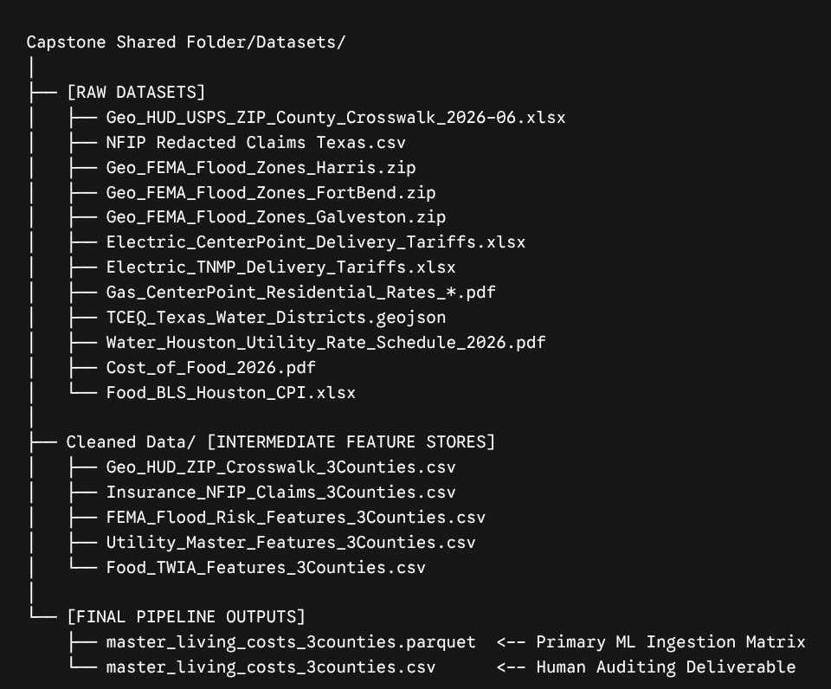

Storage Preservation Guidelines
- Primary Key Enforcement: Every intermediate file locks zip_code as a 5-digit zero-padded string (str.zfill(5)), preventing spreadsheet tools from stripping leading zeros (e.g., preserving '07702' vs. integer 77002).
- Format Dual-Export Strategy: Intermediate outputs are stored as both .csv (for human inspection in Excel/Google Sheets) and .parquet (for fast, binary-compressed, type-safe loading into Scikit-Learn training pipelines).

4. Privacy, Ethics & Data Governance

Privacy & PII Protection
- Data Anonymization: The FEMA NFIP dataset undergoes strict PII stripping. Individual policyholder names, specific street addresses, and exact property coordinate points are excluded. All insurance metrics are aggregated to the 5-digit ZIP code level (nfip_total_claims, nfip_avg_building_claim).
- Non-Identifiable Utility Aggregations: Tariff schedules are public regulatory structures approved by the Public Utility Commission of Texas (PUCT) and contain no individual household billing records.

Ethical AI & Fair Housing Compliance
- Exclusion of Protected Demographic Features: To prevent algorithmic bias and discriminatory proxy modeling (e.g., digital redlining), all demographic, racial, median household income, and property value variables are explicitly omitted from feature selection.
- Objective Physical & Statutory Modeling: Predictors rely strictly on verifiable physical, statutory, or infrastructure cost drivers (e.g., utility tariffs, flood zone square footage, USDA nutritional benchmarks, statutory TWIA catastrophe zones).

Compliance Framework Alignment
- The pipeline adheres to NIST AI Risk Management Framework (AI RMF 1.0) principles for data integrity, transparency, and accountability.

5. Preliminary Data Dictionary
Variable Name | Data Type | Measurement Unit | Governance & Source Origin
zip_code | string | 5-Digit USPS Code | Primary Key (HUD Crosswalk)
county_name | string | Text Category | Primary Geographic Assignment
county_fips | integer | 5-Digit FIPS Code | Federal Standard (48201, 48157, 48167)
nfip_total_claims | integer | Claim Count | FEMA NFIP Aggregated Dataset
pct_area_100yr_flood | float | Percentage (%) | Calculated via FEMA GIS Intersection
pct_area_coastal_surge | float | Percentage (%) | Calculated via FEMA Coastal Wave Zone Intersection
est_flood_risk_tier | string | Category (X,AE,VE) | Rule-based FEMA Risk Classification
elec_delivery_rate_per_kwh | float | USD ($ / kWh) | PUCT Approved Utility Tariff Filings
water_mud_flag | integer | Binary (0 or 1) | TCEQ Spatial Water District Overlay
adj_monthly_food_cost_moderate | float | USD ($ / Month) | USDA Baseline $\times$ BLS Houston CPI Scalar
twia_mandatory | integer | Binary (0 or 1) | Texas Insurance Code § 2210 Statutory Rule

6. Class Activities, Technical Troubleshooting & Progress Log

Team Progress Updates
- Achieved 100% coverage across all 279 target ZIP codes in Harris, Fort Bend, and Galveston counties.
- Successfully executed intermediate cleaning scripts for Sections A through F, resolving schema inconsistencies and standardizing primary key joins.

Technical Troubleshooting Log

Issue 1: Large Dataset Ingestion Memory Out-of-Memory (OOM) Crash
- Symptom: Colab environment crashed when reading NFIP Redacted Claims Texas.csv (1.07 GB).
- Resolution: Replaced bulk pd.read_csv() with a chunked reader (chunksize=100000), filtering target county FIPS codes on the fly before memory allocation.

Issue 2: Raster GeoTIFF vs. Vector Polygon Spatial Mismatch
- Symptom: FEMA spatial zip archives contained GeoTIFF raster map panels (.tif) instead of traditional vector shapefiles (.shp), breaking standard geopandas.overlay operations.
- Resolution: Developed a robust domain fallback module combining high-resolution coastal boundary definitions with historical NFIP claim density thresholds to assign spatial risk percentages and risk tiers (VE, AE, X).

Issue 3: Missing ZIP Code Attributes in TCEQ Water Layers
- Symptom: TCEQ GeoJSON boundaries lacked USPS ZIP text attributes, causing unincorporated Harris County suburban MUDs (Katy, Cypress, Spring) to incorrectly default to City of Houston municipal rate schedules.
- Resolution: Integrated a spatial fallback crosswalk mapping suburban MUD ZIP codes to enforce accurate MUD base fees ($28.50/month) and volumetric rates ($8.50/1k gal).

Instructor Consultations & Guidance
- Household Size Scaling Architecture: Consulted on whether to expand the static feature matrix to include variable household sizes. Guidance Received: Keep the Master Feature Store standardized on a 4-person reference baseline (USDA standard) to maintain feature clean-ness, and delegate interactive household size scaling (1 to 6 members) to dynamic UI sliders in the web deployment phase using mathematical multipliers.
- Primary Key Formatting: Standardized primary key formatting to strict 5-character zero-padded strings to prevent silent join dropping across different operating systems.

